ASSESSMENT TOOL 1 – Constraint-Based Problem Solving:

Q1:
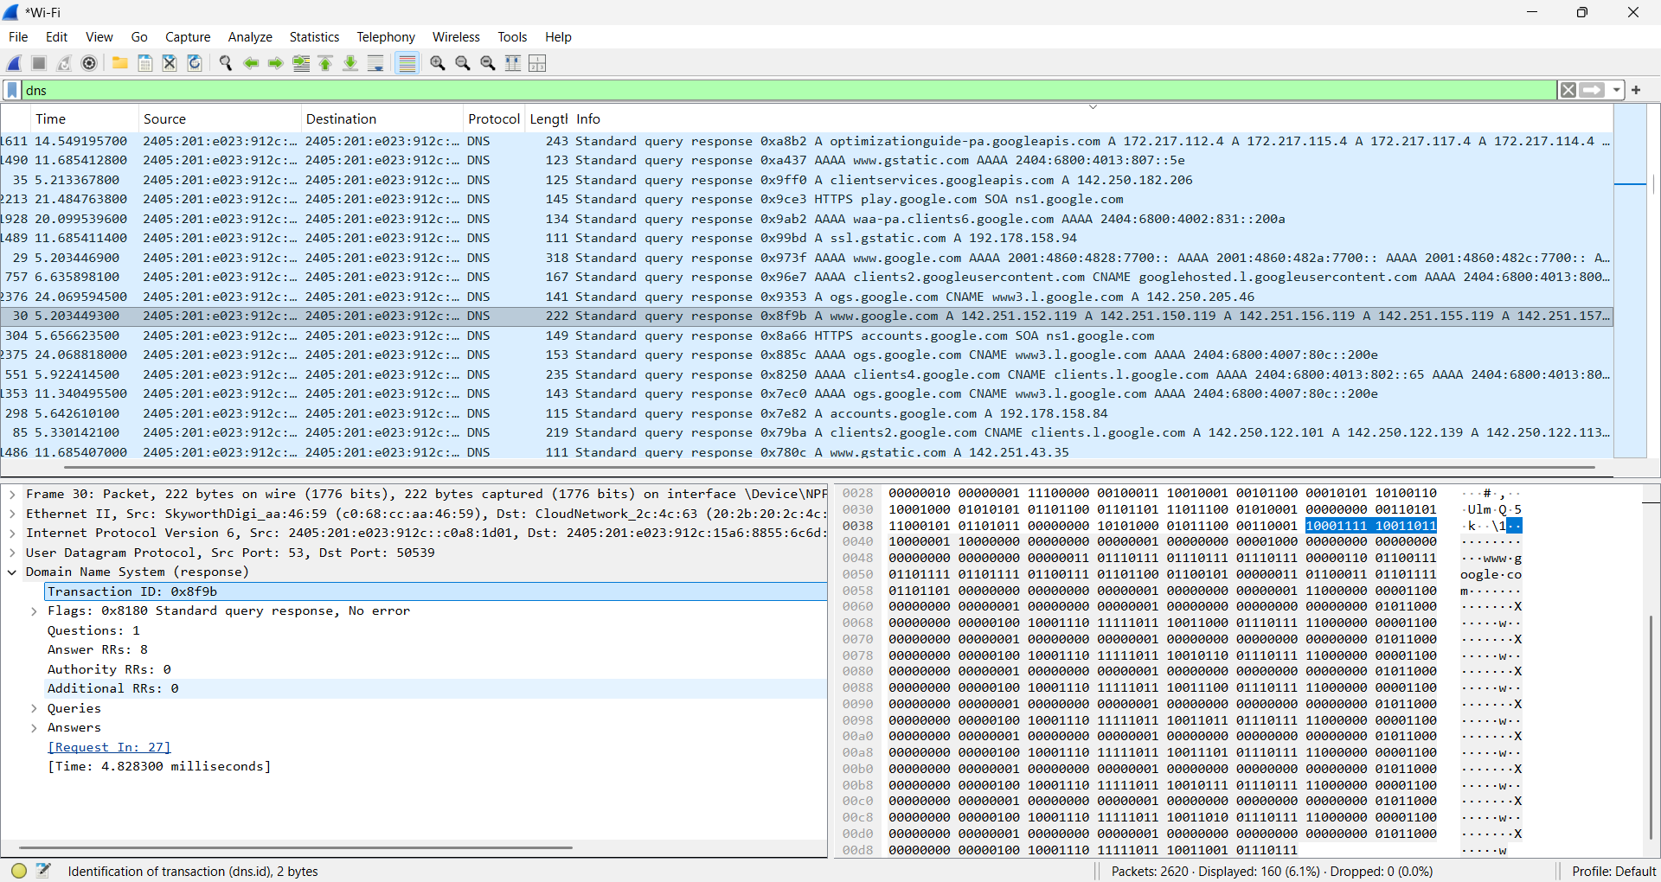
Q1 DNS, this question involves capturing and analyzing DNS traffic using Wireshark.

Q2:
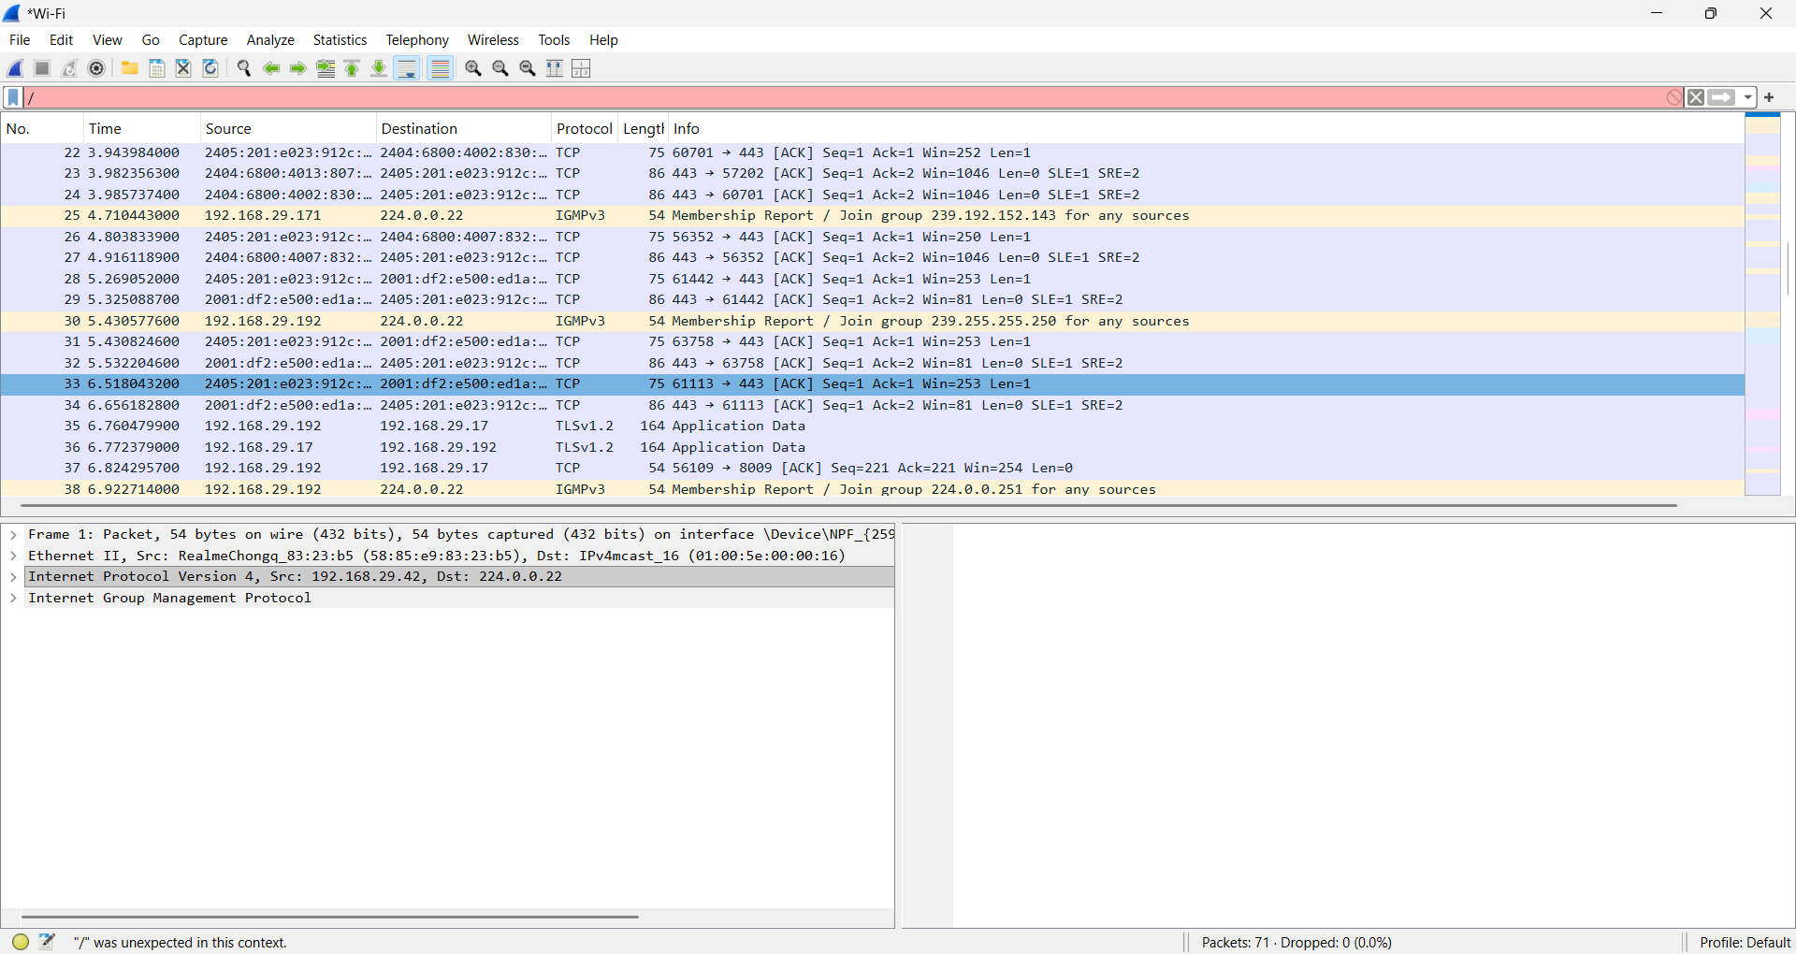
This question involves capturing and analyzing HTTP traffic while accessing a media webpage.

Q3:
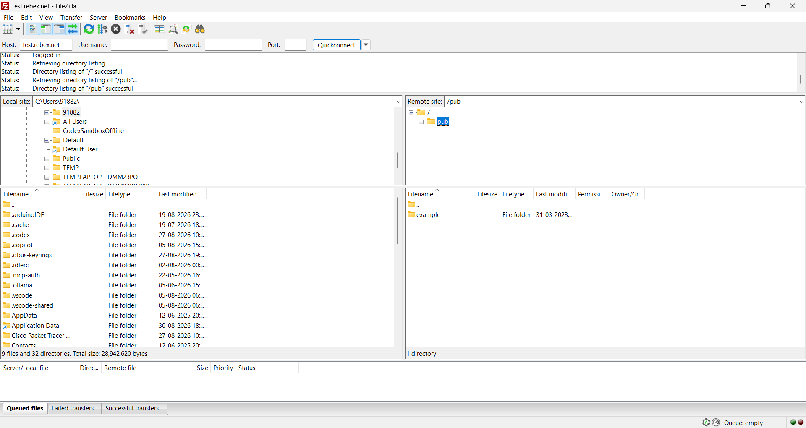
This question involves capturing and analyzing FTP file transfer traffic using Wireshark.

Q4:
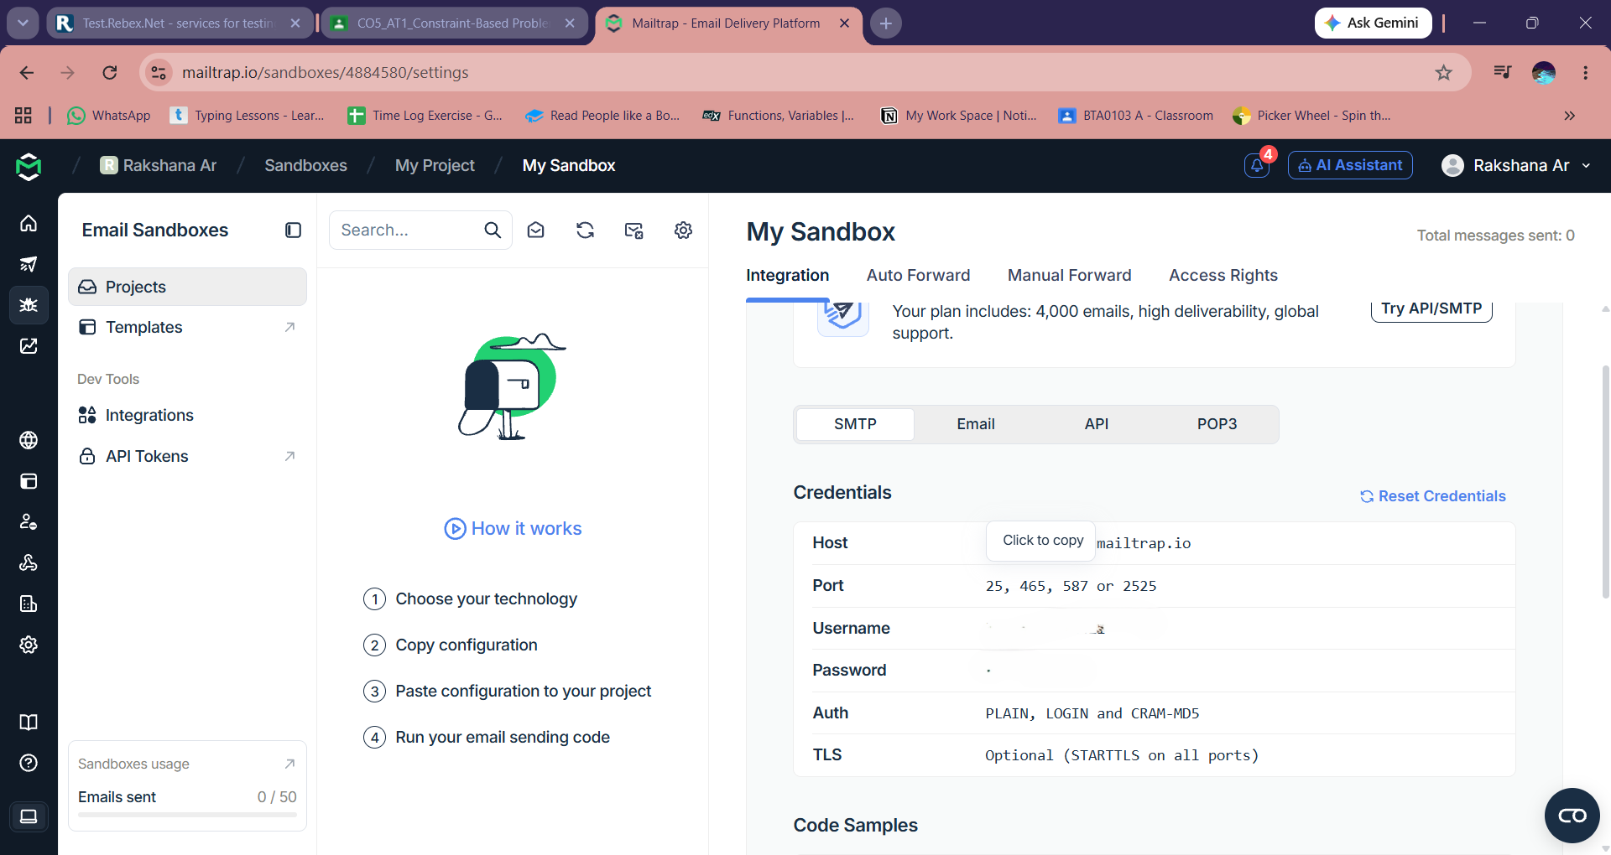
This question involves configuring Mailtrap SMTP settings and analyzing SMTP email traffic using Wireshark.

